Comp 8006 Assignment 2

Network Emulator

By: Peyman

& John Warren

For: Aman Abdulla

Due: Feb 15, 2018
Table of Contents
Design Work 3
Objective 3
Usage 3
Specifications 3
Set up 4
State Machine 4
Pseudo Code 5
Test Plan & Results 5
Inbound 5
Outbound 7

Design Work

Objective
To design, implement and test a standalone Linux firewall and packet filter

Usage
Firewall
Run with root access ./fw0.sh
Client
Run with root access ./client_setup.sh

Specifications
1 - use netfilter
2 - load user configuration for all forwarded traffic
3 - set default policies for firewall
4 - dns, dhcp enabled
5 - in/out tcp/udp ports, icmp types
6 - default rule = drop
7 - reject wrong way (i.e. syn in on high ports)
8 - accept fragments
9 - drop tcp with SYN & FIN set
10 - no telnet packets allowed
11 - block external
111, 137-139, 515, 32768-32775
12 - ftp/ssh minimum delay,
13 - ftp max thruput
14 - first [en01] = outside, second [enp3s2] = inside
15 - test procedure; test rules, print results (log)
16 - need to know which rule passed/failed
17 - Allow user to define own rules
18 – separate file for config
19 – define network interfaces
20 – define allowed tcp, udp, icmp
21 – stateful filtering

Set up
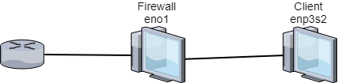

State Machine
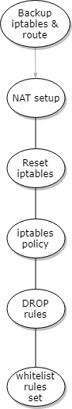

Pseudo Code
User Variables
1 – Provide variables to allow user to define values for internal and external interfaces, subnets and IP addresses.
2 – Allow user to define what ports to allow for udp and tcp and icmp types

Configure Firewall
- Backup existing configuration
- configure network cards
- Flush existing configuration
- apply default rule and drop all packets
- define chains
- apply user rules, assigning chains for each of tcp, udp, icmp
  - for each port, apply rule, add to chain

Configure client
- Backup current config
- Disable primary network
- Connect network cable
- Configure internal network card

Test Plan & Results
Usage ‘./test.sh <IP of target>’ on either client for outbound or another machine on the network for inbound

Inbound
Testing | Test method | expected | Result
TCP port 22 | hping3 ip -V -S -p 22 -c 1 | ALLOWED | PASS
TCP port 80 | hping3 ip -V -S -p 80 -c 1 | ALLOWED | PASS
TCP port 443 | hping3 ip -V -S -p 443 -c 1 | ALLOWED | PASS
UDP port 53 | hping3 ip -V –udp -S -p 53 -c 1 | ALLOWED | FAILED
UDP port 67 | hping3 ip -V –udp -S -p 67 -c 1 | ALLOWED | FAILED
UDP port 68 | hping3 ip -V –udp -S -p 68 -c 1 | ALLOWED | FAILED
ICMP port 0 | hping3 ip -V -1 -S -p 0 -c 1 | ALLOWED | FAILED
ICMP port 8 | hping3 ip -V -1 -S -p 8 -c 1 | ALLOWED | FAILED
TCP port 23 | hping3 ip -V -S -p 23 -c 1 | DROPPED | PASS
TCP port 111 | hping3 ip -V -S -p 111 -c 1 | DROPPED | PASS
TCP port 137 | hping3 ip -V -S -p 137 -c 1 | DROPPED | PASS
TCP port 138 | hping3 ip -V -S -p 138 -c 1 | DROPPED | PASS
TCP port 139 | hping3 ip -V -S -p 139 -c 1 | DROPPED | PASS
TCP port 515 | hping3 ip -V -S -p 515 -c 1 | DROPPED | PASS
TCP port 32768 | hping3 ip -V -S -p 32768 -c 1 | DROPPED | PASS
TCP port 32775 | hping3 ip -V -S -p 32775 -c 1 | DROPPED | PASS
UDP port 23 | hping3 ip -V –udp -1 -S -p 0 -c 1 | DROPPED | PASS
UDP port 111 | hping3 ip -V –udp -1 -S -p 8 -c 1 | DROPPED | PASS
UDP port 137 | hping3 ip -V –udp -S -p 23 -c 1 | DROPPED | PASS
UDP port 138 | hping3 ip -V –udp -S -p 111 -c 1 | DROPPED | PASS
UDP port 139 | hping3 ip -V –udp -S -p 137 -c 1 | DROPPED | PASS
UDP port 515 | hping3 ip -V –udp -S -p 138 -c 1 | DROPPED | PASS
UDP port 32768 | hping3 ip -V –udp -S -p 139 -c 1 | DROPPED | PASS
UDP port 32775 | hping3 ip -V –udp -S -p 515 -c 1 | DROPPED | PASS
ICMP port 200 | hping3 ip -V -1 -S -p 200 -c 1 | DROPPED | PASS
TCP SPOOF | hping3 ip -V -c 1 -S -s 80 -p 80 --spoof 192.168.10.5 | DROPPED | PASS
TCP SYN FIN | hping3 ip -V -c 1 -s 1000 -p 80 -SF | DROPPED | PASS
UDP fragment | hping3 ip -V -S -p 22 -c 1 -f | DROPPED

SSH in - Connected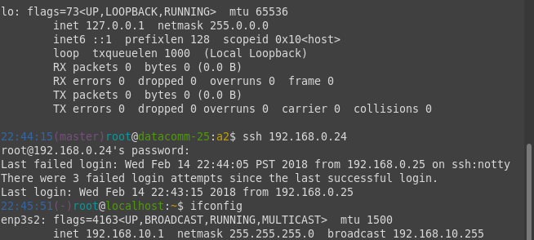

Outbound
Testing | Test method | expected | Result
TCP port 22 | hping3 ip -V -S -p 22 -c 1 | ALLOWED | PASS
TCP port 80 | hping3 ip -V -S -p 80 -c 1 | ALLOWED | PASS
TCP port 443 | hping3 ip -V -S -p 443 -c 1 | ALLOWED | PASS
UDP port 53 | hping3 ip -V –udp -S -p 53 -c 1 | ALLOWED | PASS
UDP port 67 | hping3 ip -V –udp -S -p 67 -c 1 | ALLOWED | PASS
UDP port 68 | hping3 ip -V –udp -S -p 68 -c 1 | ALLOWED | PASS
ICMP port 0 | hping3 ip -V -1 -S -p 0 -c 1 | ALLOWED | PASS
ICMP port 8 | hping3 ip -V -1 -S -p 8 -c 1 | ALLOWED | PASS
TCP port 23 | hping3 ip -V -S -p 23 -c 1 | DROPED | PASS
TCP port 111 | hping3 ip -V -S -p 111 -c 1 | DROPED | PASS
TCP port 137 | hping3 ip -V -S -p 137 -c 1 | DROPED | PASS
TCP port 138 | hping3 ip -V -S -p 138 -c 1 | DROPED | PASS
TCP port 139 | hping3 ip -V -S -p 139 -c 1 | DROPED | PASS
TCP port 515 | hping3 ip -V -S -p 515 -c 1 | DROPED | PASS
TCP port 32768 | hping3 ip -V -S -p 32768 -c 1 | DROPED | PASS
TCP port 32775 | hping3 ip -V -S -p 32775 -c 1 | DROPED | PASS
UDP port 23 | hping3 ip -V –udp -1 -S -p 0 -c 1 | DROPED | PASS
UDP port 111 | hping3 ip -V –udp -1 -S -p 8 -c 1 | DROPED | PASS
UDP port 137 | hping3 ip -V –udp -S -p 23 -c 1 | DROPED | PASS
UDP port 138 | hping3 ip -V –udp -S -p 111 -c 1 | DROPED | PASS
UDP port 139 | hping3 ip -V –udp -S -p 137 -c 1 | DROPED | PASS
UDP port 515 | hping3 ip -V –udp -S -p 138 -c 1 | DROPED | PASS
UDP port 32768 | hping3 ip -V –udp -S -p 139 -c 1 | DROPED | PASS
UDP port 32775 | hping3 ip -V –udp -S -p 515 -c 1 | DROPED | PASS
ICMP port 200 | hping3 ip -V -1 -S -p 200 -c 1 | DROPED | PASS
TCP SPOOF | hping3 ip -V -c 1 -S -s 80 -p 80 --spoof 192.168.10.5 | DROPPED | PASS
TCP SYN FIN | hping3 ip -V -c 1 -s 1000 -p 80 -SF | DROPPED | PASS
UDP fragment | hping3 ip -V -S -p 22 -c 1 -f | DROPPED

SSH out test
